**MongoDb**

**&**

**MySql**

**Assessment**



Name – Maithely Sharma

College – University of Petroleum and Energy Studies

EmployeeID – 4057

1. **install latest version of MongoDB from apt-get repository**

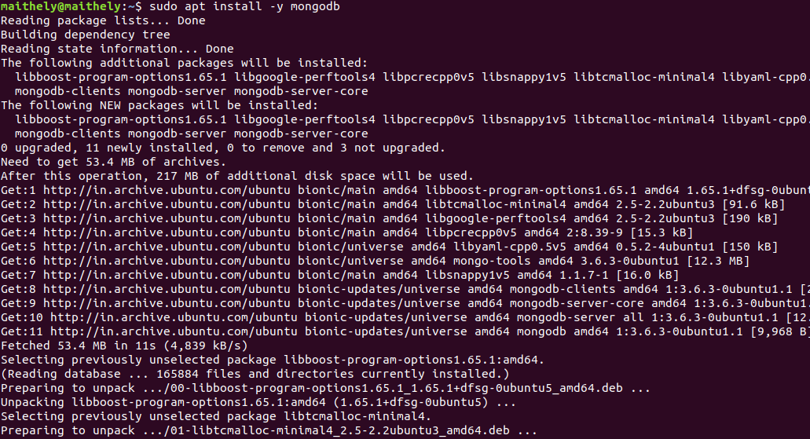

1. **Create a database student**

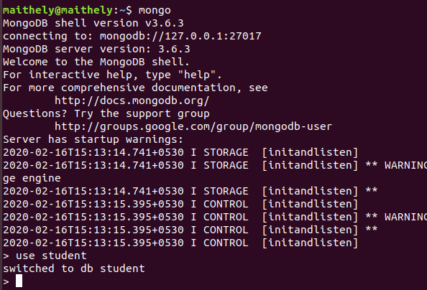

1. **Insert operation : 5 students data (Name, Contact, City, Roll No, Branch)**

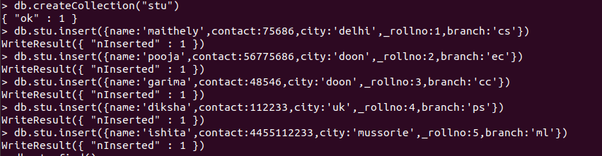

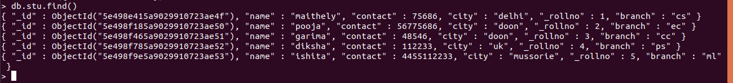

1. **Read operation : All the students belong to a particular city**

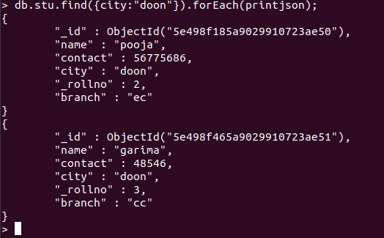

1. **Update operation : Update the branch of all the students to CSE**

**> db.stu.update({'branch':'cs'},{$set:{'branch':'CSE'}},{multi:true})**

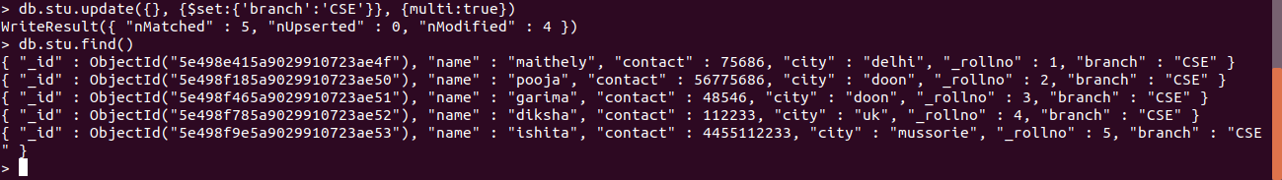

1. **Take dump of the database**

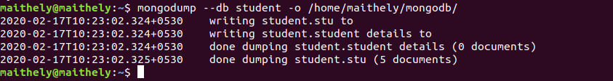

1. **Delete operation : Delete the record of last 2 students according to the roll number**

**db.stu.remove( { _rollno : { $gt: 3 } })**

1. **Drop the database**
2. **Restore the database again to have the full data**

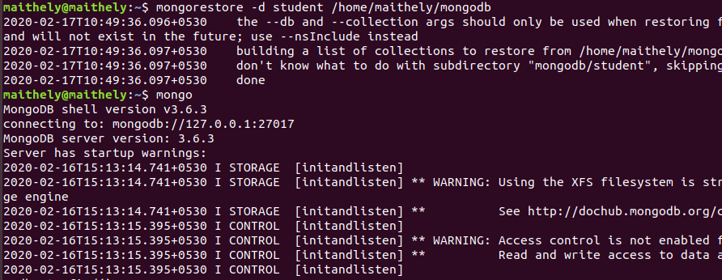

1. **Enable authentication on the Mongo**

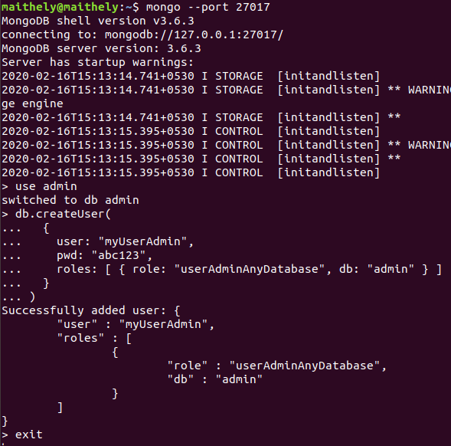

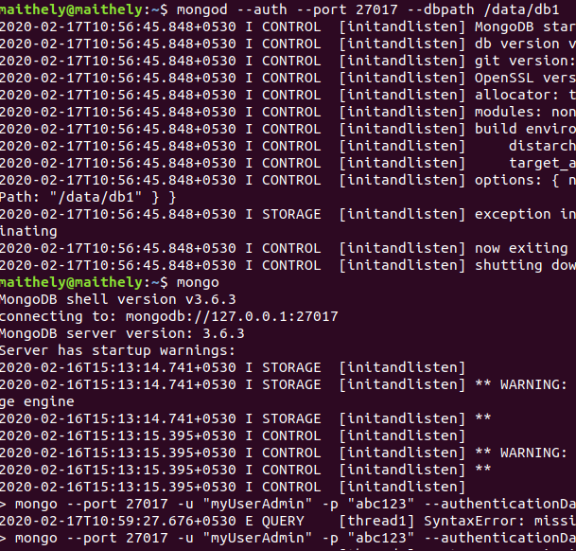

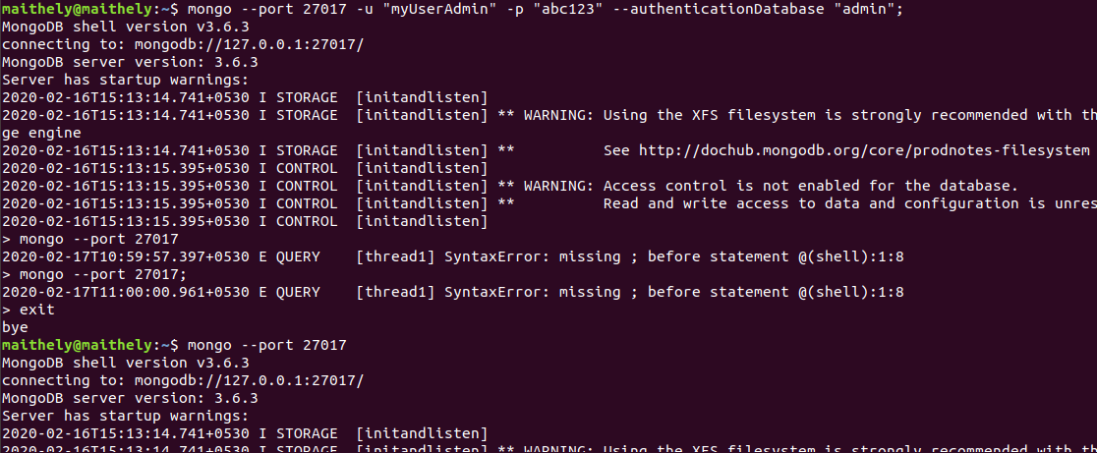

1. **Install another version of MongoDB from source (Version 2.6.3) and run it on port 27009**
2. **Create init service of Mongo installed later*  
     
     
   MySQL**
3. **Install latest version of MongoDB from apt-get repository**

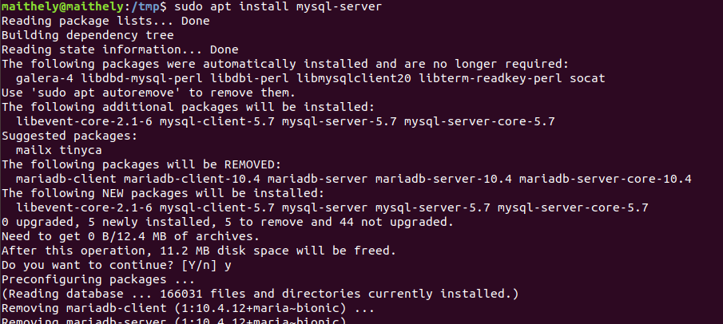

1. **Create a database student**

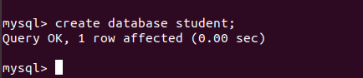

1. **Insert operation : 5 students data (Name, Contact, City, Roll No, Branch)**

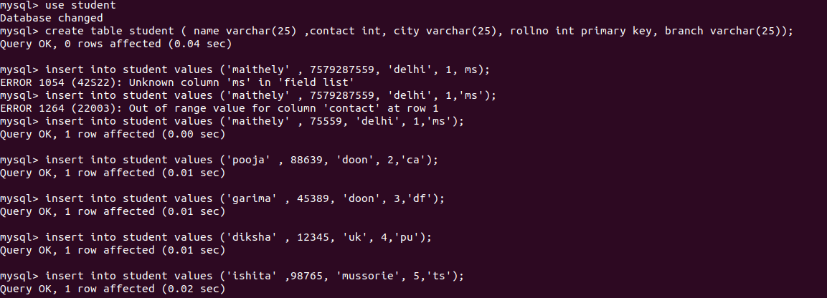

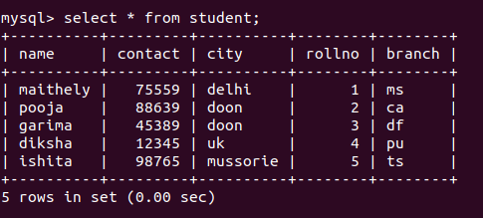

1. **Read operation : All the students belong to a particular city**

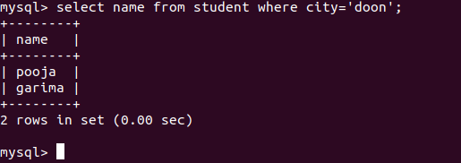

1. **Update operation : Update the branch of all the students to CSE**

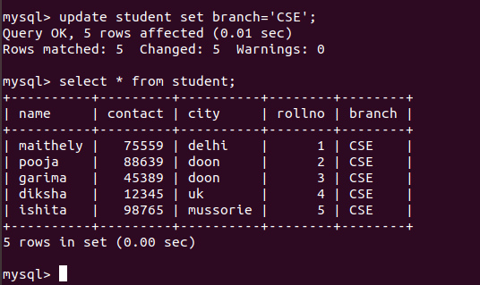

1. **Take dump of the database**

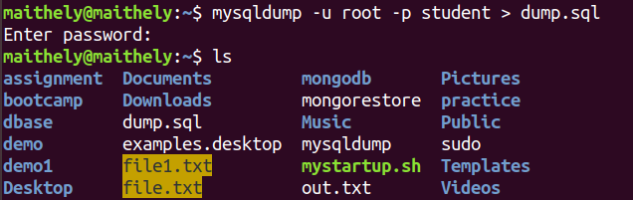

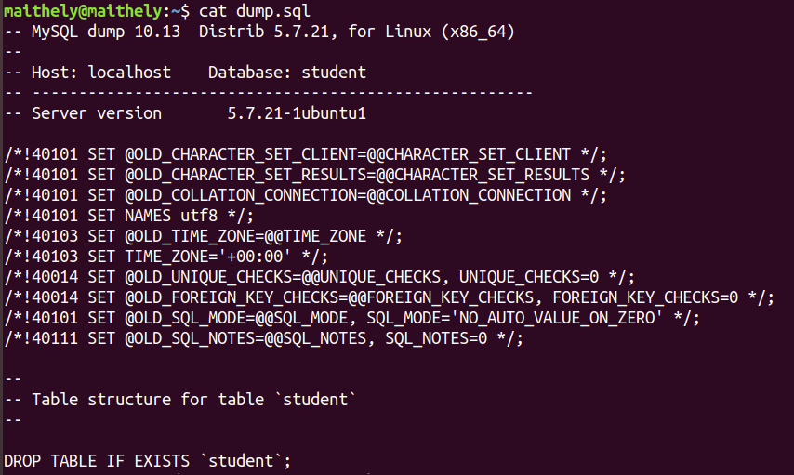

1. **Delete operation : Delete the record of last 2 students according to the roll number**

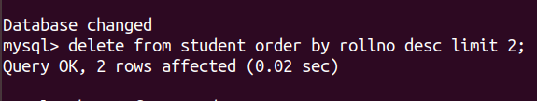

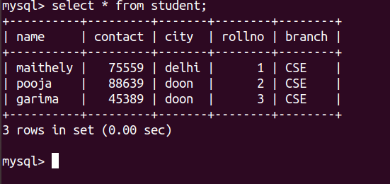

1. **Drop the database**

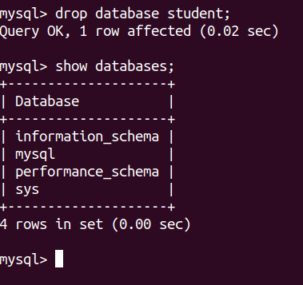

1. **Restore the database again to have the full data**

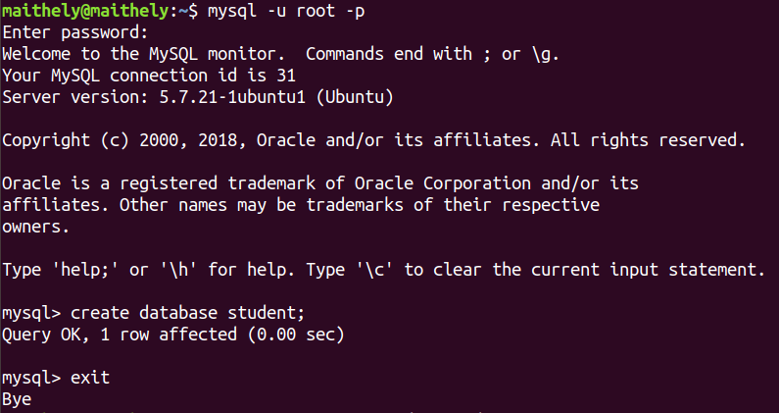



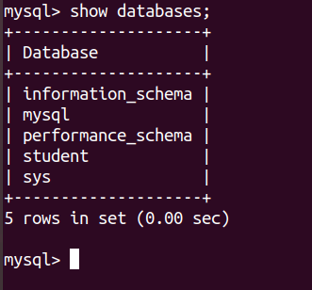

1. **Enable authentication on the Mongo**

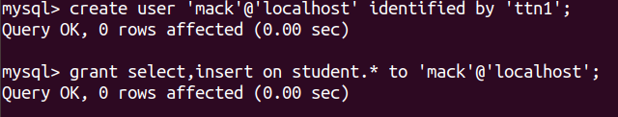

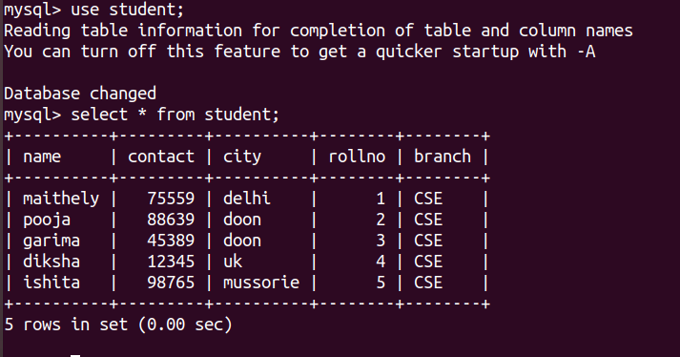

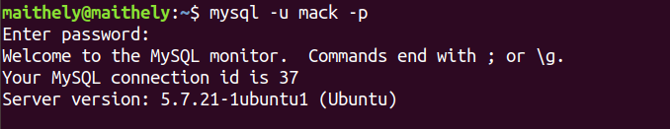

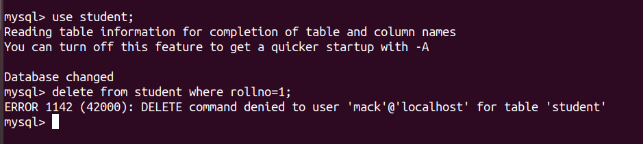

1. **Install another version of MongoDB from source (Version 2.6.3) and run it on port 27009**
2. **Create init service of Mongo installed later\***